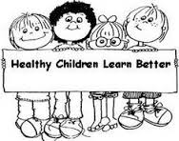

September School Nurse Newsletter

from Nurse Kris

Healthy brains and healthy bodies are vital to learning. If you ask most students who come into the nurse’s office for one reason or another, my advice is often the same, “Drink water, and lots of it!” Being well hydrated, along with eating well-balanced meals and being physically active, will help students feel better, think better and learn better!

**Here are 7 Habits of Healthy Kids:**

1. Practice good hygiene by WASHING YOUR HANDS especially before you eat!
2. Stay energized by eating nutritious meals and snacks. Eat a healthy breakfast every morning!
3. Get a good night’s rest. School aged children need at least 8-10 hours of sleep per night.
4. EXERCISE! Run, walk, stretch and play!
5. Brush your teeth and floss every day!
6. Cover your mouth when you cough or sneeze to keep from spreading germs.
7. Make good choices for a happy, healthy, YOU!

** Please send an extra change of clothes for your child to keep at school, accidents happen!